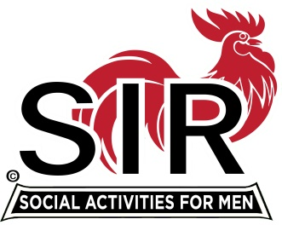
Las Trampas Branch 116
BEC Meeting Agenda
February 15, 2021, 8:30 AM
The Mission of SIR is to enhance the lives of our members through fun activities, events and luncheons – while making friends for life.

8:30 am Call to order; Secretary confirm a quorum
8:35 Secretary – Alan Pope [for Paul Ramacciotti] – Approval of January 2021 minutes
8:40 Treasurer –/Alan Fitzgerald – Report
8:45 Standing Reports
- Membership – Phil Goff
- RAMP Department Head Reports:
- Recruitment
- Activity Coordinator
- Member relations
- Publicity

9:00 Big SIR Report – Sam Beret

- February 15 monthly meeting agenda
- State SIR Covid Survey
- Speakers Committee –GREAT JOB!!
- Contributions to “SIR Happenings”
9:15 Little SIR Report - Fred Wachowicz
1. Speaker:
2- Birthday Boys
3- Diversity Team Report
9:25 Virtual Lunch Zoom Process - Neil Schmidt
9:30 Old Business
- TBA
New Business:
- Approve Branch Golf activities subject to: 1- Health Directives from CA and Contra Costa County, 2- State SIR Directives, 3- Branch Golf Protocol

Resolution recommended by State SIR
**********************

SIR Outdoor Activities
Branch BEC Resolution

RESOLVED, that all SIR sponsored (name of activity) are henceforth approved by SIR Branch (branch #) provided: (Branch number)
- such activities are not prohibited by an applicable order of the California Department of Public Health or County or Municipal Health Department, and
- all activities are conducted under written protocols in a strict compliance with all applicable State and Locally mandated mask, hand sanitizing, distancing requirements, and any other pertinent Health Related Requirements.
The Resolution and the written protocols must be passed by the Branch BEC and recorded in the Branch minutes.
**************************************

9:45 Other Discussion

10:00 Adjourn; Next BEC Meeting, March 15, 2021

Join Zoom Meeting Weblink
https://us02web.zoom.us/j/85332344422
Meeting ID: 853 3234 4422
Passcode: 612956
Dial by home phone: (669) 900-9128

